UNITED STATES

SECURITIES AND EXCHANGE COMMISSION

Washington, D.C. 20549

SCHEDULE 14A

(RULE 14A-101)

INFORMATION REQUIRED IN PROXY STATEMENT

SCHEDULE 14A INFORMATION

Proxy Statement Pursuant to Section 14(a) of the Securities Exchange Act of 1934 (Amendment No.

)

Filed by the Registrant ☑

Filed by a Party other than the Registrant o

Check the appropriate box:

o Preliminary Proxy Statement

o Confidential, for Use of the Commission Only (as permitted by Rule 14a-12))

o Definitive Proxy Statement

o Definitive Additional Materials

- Soliciting Material Pursuant to § 240.14a-11(c) or § 140.14a-12

BIOSCRIP, INC.

(Name of Registrant as Specified in Its Charter)

(Name of Person(s) Filing Proxy Statement)

Payment of Filing Fee (Check the appropriate box):

- No fee required.

- Fee computed on table below per Exchange Act Rules 14a-6(i)(1) and 0-11.

  - Title of each class of securities to which transaction applies:

  - Aggregate number of securities to which transaction applies:

  - Per unit price or other underlying value of transaction computed pursuant to Exchange Act Rule 0-11 (set forth the amount on which the filing fee is calculated and state how it was determined):

  - Proposed maximum aggregate value of transaction:

  - Total fee paid:

- Fee paid previously with preliminary materials.

- Check box if any part of the fee is offset as provided by Exchange Act Rule 0-11(a)(2) and identify the filing for which the offsetting fee was paid previously. Identify the previous filing by registration statement number, or the Form or Schedule and the date of its filing.

  - Amount Previously Paid:

  - Form, Schedule or Registration Statement No.:

  - Filing Party:

  - Date Filed:

Filed by BioScrip, Inc. Pursuant to Rule 14a-12
Under the Securities Exchange Act of 1934

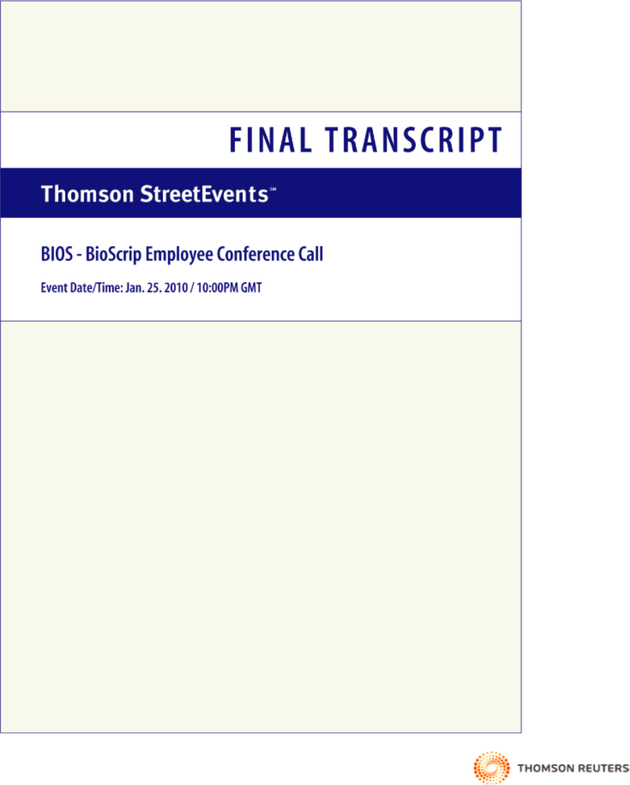

THOMSON REUTERS STREETEVENTS | www.streetevents.com | Contact Us

©2010 Thomson Reuters. All rights reserved. Republication or redistribution of Thomson Reuters content, including by framing or similar means, is prohibited without the prior written consent of Thomson Reuters. ‘Thomson Reuters’ and the Thomson Reuters logo are registered trademarks of Thomson Reuters and its affiliated companies.

FINAL TRANSCRIPT

Jan. 25. 2010 / 10:00PM, BIOS — BioScrip Employee Conference Call

CORPORATE PARTICIPANTS

Rich Friedman

BioScrip, Inc. — Chairman, CEO

Rick Smith

BioScrip, Inc. — President, COO

Lisa Nadler

BioScrip, Inc. — Sr. VP Human Resources

CONFERENCE CALL PARTICIPANTS

Vito Ponzio

PRESENTATION

Lisa Nadler — BioScrip, Inc. — Sr. VP Human Resources

Good afternoon. Hi. It’s Lisa Nadler. We’re here to talk to you. I have Rich and Rick in the room with me. We’re here to talk to you about the news that we announced this morning about the acquisition of CHS. They’re going to take you through a little bit of the news and then we’ll open it up for a short Q&A. And thanks for joining us.

Thank you, Lisa. Good afternoon, everyone. It’s Rich Friedman. I hope everybody’s doing well.

It’s been exciting times for us and for all of us over at BioScrip. As you all are now aware, we announced this morning that we signed a deal to acquire Critical Homecare Solutions, CHS. We think it’s an incredible fit for BioScrip, to the family of BioScrip. It’s an organization that has built itself up in the infusion marketplace and nursing care.

The company does approximately $260 million, throws off pretty significant earnings EBITDA over the last 12 months, ended September of about $39 million. The reason that we were pretty much excited about doing this acquisition is because we do believe it fits dramatically with BioScrip. As all of you know, BioScrip has been a company that has grown over the years, where the Company is doing about $1.4 billion today, where our margins on a gross profit line are at about 11.5% range.

And what this has done, this is a company that generates gross profits in the 50% range. It adds therapies to what we’re doing today, even though we’re doing it out of Infusion West. This really creates larger scale for us with these particular products, especially in the parenteral nutritional products and TPNs.

We think it dramatically increases our footprint. It adds significantly again to the EBITDA. It brings clinical expertise, which is something that we’ve looked for for the last year and a half. So, overall, from a financial standpoint, we believe that it helps us dramatically to improve earnings within the Company.

This is an expansion for us in terms of BioScrip and its employees. These are separate locations for the most part. There’s a heavy concentration in the Midwest to the east. There are 35 infusion centers, 33 nursing locations, and it’s a complement to what we do. So, we’re looking forward to it. There’s going to be a lot of hard work in the months ahead. We’re anxious about it.

And with that, I’ll turn it over to Rick to talk about it from the operational standpoint. And then we’ll be happy to answer questions that any of you may have. Rick?


THOMSON REUTERS STREETEVENTS | www.streetevents.com | Contact Us

©2010 Thomson Reuters. All rights reserved. Republication or redistribution of Thomson Reuters content, including by framing or similar means, is prohibited without the prior written consent of Thomson Reuters. ‘Thomson Reuters’ and the Thomson Reuters logo are registered trademarks of Thomson Reuters and its affiliated companies.

1

FINAL TRANSCRIPT

Jan. 25. 2010 / 10:00PM, BIOS — BioScrip Employee Conference Call

Rick Smith — BioScrip, Inc. — President, COO

Thanks, Rich. Good afternoon, everyone. It’s a pleasure to be here talking about this opportunity for us. I think since I joined this organization, I think we’ve been pretty clear in terms of what our objectives are, and that is to be the clinical leader in all technologies, infusion, oral and injectable.

I know that in all of our locations we struggle with holding on to patients, having access to patients, struggling with not being in control of our network, and essentially being sometimes carved out of access to patients due to network participation. One of the things that has been a high priority for us and for me has been really to strengthen and enlarge our direct payer contracting situation here at BioScrip.

I think that one of the first things that we focused in on was getting a United relationship agreement in terms of the infusion opportunity, which is now leading to some specialty pharmacy opportunities. This acquisition will come with 450 plus managed care relationships. These are direct contracts that will enable us to offer an opportunity to cross-sell and up-sell direct specialty pharmacy relationships.

I think that given where we want to go with our platform of community pharmacies and our central mail order pharmacy plus our infusion division, it is to continue to expand access through direct contracts, direct contract relationships, as we look to expand our capabilities and our opportunities to deliver clinical services at all of our locations.

And so I think this is a very significant and substantial step towards our progress on our strategic plan. And I think it’s a significant step towards strengthening our organization in terms of clinical offerings and providing access to more clinical programs than we have today in BioScrip on the infusion side.

So I’m very excited. I look forward to you continuing to do what you do great in terms of taking care of our patients. I need you to continue to stay focused on what we do every day. I need you to stay focused on the objectives that we have for 2010. I also ask you on the infusion division not to reach out to anyone at the CHS locations. We have an integration plan that is being headed by Dave Evans and the corporate team. So any questions run through him. Just because we don’t own them yet, there’s still a lot of work to do, and we don’t want to start giving direction to the CHS people ahead of permissible opportunities or permissible timelines.

The other thing that we need to make sure of is that there is no overlap essentially with our locations and operations and theirs and the business that they do and we do. And so the beauty here is that we have an opportunity to bring all of their personnel on staff with us without any disruption or distraction or concern for jobs and opportunities to continue to have a career path here at BioScrip and post combination.

So I’m very excited. It’s a great deal, as Rich mentioned. And it’s a great step for us and the future of BioScrip as the leading independent specialty pharmacy and the home infusion provider in the industry.

Rich Friedman — BioScrip, Inc. — Chairman, CEO

And I guess just one more point before we open it up. And also with us is Barry, Stan and Phil if anyone has questions for them.

Looking at 2010, we put this out today and I think you should all be aware of it. What BioScrip is looking for is revenues between $1.67 billion and $1.73 billion, with gross profit of around $267 million to $277 million, and EBITDA, which is earnings before interest, taxes, depreciation, amortization and option expense, of between $67 million to $71 million. And that’s including nine months of CHS.

THOMSON REUTERS STREETEVENTS | www.streetevents.com | Contact Us

©2010 Thomson Reuters. All rights reserved. Republication or redistribution of Thomson Reuters content, including by framing or similar means, is prohibited without the prior written consent of Thomson Reuters. ‘Thomson Reuters’ and the Thomson Reuters logo are registered trademarks of Thomson Reuters and its affiliated companies.

2

FINAL TRANSCRIPT

Jan. 25. 2010 / 10:00PM, BIOS — BioScrip Employee Conference Call

And the real key there is effectively from looking at BioScrip, even though it’s only — well, actually, for the year it’s about $180 million for the nine-month period. It’s almost doubling up on the EBITDA that we’ve experienced in the past. It increases our margins by 600 basis points and our gross profit and our EBITDA margins by 200 basis points.

There’s a question that I’m sure has come up, which is the amount of debt that BioScrip is taking on to go fund this. We look at things in terms of leverage, which is the amount of debt over the earnings that are being generated. And we all feel, including our financial advisors and our board, that the amount of debt that we’re taking on, even though it may appear a little bit high, is absolutely reasonable for this type of transaction. And for all of you to rest assured that we will be generating significant cash flows in order to pay down the debt as quickly as possible. So from the liquidity and balance sheet standpoint, we’re very optimistic. We’re very pleased with where we will be.

So, with that, if anybody else, Barry, Stan, Phil, anything to add, we will be happy to open up the line for questions.

QUESTIONS AND ANSWERS

Lisa Nadler — BioScrip, Inc. — Sr. VP Human Resources

Operator, can you please go ahead and open up the lines?

Operator

(Operator Instructions).

Lisa Nadler — BioScrip, Inc. — Sr. VP Human Resources

So, no questions at this time?

Operator

We do have a question. Hold on, please.

Your first question comes from the line of Vito Ponzio

Rich Friedman — BioScrip, Inc. — Chairman, CEO

Hi, Vito.

Vito Ponzio

Actually, the question’s from — good afternoon, everyone. First of all, congratulations. Barbara Patton had a question on the number of employees that will be coming over with the acquisition.

Rick Smith — BioScrip, Inc. — President, COO

There’s over 1,100 fulltime employees that are — exist, almost evenly split on the nursing and the infusion side. Just under 1,200 as of earlier this year.

THOMSON REUTERS STREETEVENTS | www.streetevents.com | Contact Us

©2010 Thomson Reuters. All rights reserved. Republication or redistribution of Thomson Reuters content, including by framing or similar means, is prohibited without the prior written consent of Thomson Reuters. ‘Thomson Reuters’ and the Thomson Reuters logo are registered trademarks of Thomson Reuters and its affiliated companies.

3

FINAL TRANSCRIPT

Jan. 25. 2010 / 10:00PM, BIOS — BioScrip Employee Conference Call

Vito Ponzio

Thank you.

Operator

There are no further questions.

Rich Friedman — BioScrip, Inc. — Chairman, CEO

We’d like to thank everyone for participating. This is the first time that we’re doing this type of call. We thought it was significant enough.

On behalf of the board, the management team, we really want to thank every one of you. BioScrip has come a long way in the last number of years. We heard today that the reputation in the marketplace is second to none. We continue to move forward. And it’s all because of you. We talk about managing the chronically ill, about the difference that each one of you makes in dealing with these people on a daily basis, the difference in their lives. And that is true and that is why BioScrip continues to move forward.

So we would like to thank each one of you for your hard work, your loyalty and for what you do every single day. So on behalf of everyone, thank you very much.

Operator

This concludes today’s teleconference. You may now disconnect.


DISCLAIMER

Thomson Reuters reserves the right to make changes to documents, content, or other information on this web site without obligation to notify any person of such changes.

In the conference calls upon which Event Transcripts are based, companies may make projections or other forward-looking statements regarding a variety of items. Such forward-looking statements are based upon current expectations and involve risks and uncertainties. Actual results may differ materially from those stated in any forward-looking statement based on a number of important factors and risks, which are more specifically identified in the companies’ most recent SEC filings. Although the companies may indicate and believe that the assumptions underlying the forward-looking statements are reasonable, any of the assumptions could prove inaccurate or incorrect and, therefore, there can be no assurance that the results contemplated in the forward-looking statements will be realized.

THE INFORMATION CONTAINED IN EVENT TRANSCRIPTS IS A TEXTUAL REPRESENTATION OF THE APPLICABLE COMPANY’S CONFERENCE CALL AND WHILE EFFORTS ARE MADE TO PROVIDE AN ACCURATE TRANSCRIPTION, THERE MAY BE MATERIAL ERRORS, OMISSIONS, OR INACCURACIES IN THE REPORTING OF THE SUBSTANCE OF THE CONFERENCE CALLS. IN NO WAY DOES THOMSON REUTERS OR THE APPLICABLE COMPANY ASSUME ANY RESPONSIBILITY FOR ANY INVESTMENT OR OTHER DECISIONS MADE BASED UPON THE INFORMATION PROVIDED ON THIS WEB SITE OR IN ANY EVENT TRANSCRIPT. USERS ARE ADVISED TO REVIEW THE APPLICABLE COMPANY’S CONFERENCE CALL ITSELF AND THE APPLICABLE COMPANY’S SEC FILINGS BEFORE MAKING ANY INVESTMENT OR OTHER DECISIONS.

©2010, Thomson Reuters. All Rights Reserved.

THOMSON REUTERS STREETEVENTS | www.streetevents.com | Contact Us

©2010 Thomson Reuters. All rights reserved. Republication or redistribution of Thomson Reuters content, including by framing or similar means, is prohibited without the prior written consent of Thomson Reuters. ‘Thomson Reuters’ and the Thomson Reuters logo are registered trademarks of Thomson Reuters and its affiliated companies.

4

Additional Information and Where to Find it

BioScrip, Inc. intends to file with the Securities and Exchange Commission (the “SEC”) a proxy statement regarding the issuance of stock in connection with the proposed transaction. The proxy statement will be mailed to the stockholders of BioScrip. INVESTORS AND STOCKHOLDERS ARE ADVISED TO READ THE PROXY STATEMENT AND OTHER RELEVANT MATERIALS WHEN THEY BECOME AVAILABLE BECAUSE THEY WILL CONTAIN IMPORTANT INFORMATION ABOUT BIOSCRIP AND THE PROPOSED TRANSACTION. Investors and stockholders may obtain free copies of these documents (when they are available) and other documents filed with the SEC at the SEC’s web site at www.sec.gov. In addition, the documents filed by BioScrip with the SEC may be obtained free of charge by contacting BioScrip, Inc., Investor Relations, 100 Clearbrook Road, Elmsford, NY 10523 or contacting BioScrip, Inc. Attn: General Counsel at 914-460-1638.

Participants in the Solicitation

BioScrip and its officers and directors may be deemed to be participants in the solicitation of proxies from BioScrip’s stockholders with respect to the issuance of stock in connection with the proposed transaction. Information about BioScrip’s executive officers and directors and their ownership of BioScrip’s stock is set forth in the proxy statement for BioScrip’s 2009 Annual Meeting of Stockholders, which was filed with the SEC on March 27, 2009. Investors and stockholders may obtain more detailed information regarding the direct and indirect interests of BioScrip and its respective executive officers and directors in the proposed transaction by reading the preliminary and definitive proxy statements regarding the issuance of stock in connection with the proposed transaction, which will be filed with the SEC.

Safe Harbor Statement

This communication includes forward-looking statements regarding the proposed acquisition and related transactions that are not historical or current facts and deal with potential future circumstances and developments, in particular information regarding growth opportunities, expected synergies from the acquisition, and whether and when the transactions contemplated by the merger agreement will be consummated. Forward-looking statements are qualified by the inherent risk and uncertainties surrounding future expectations generally and may materially differ from actual future experience. Risks and uncertainties that could affect forward-looking statements include: the failure to realize synergies as a result of operational efficiencies, purchasing volume discounts, cross-selling of services, streamlined distribution and general and administrative reductions in the timeframe expected or at all; unexpected costs or liabilities; the result of the review of the proposed transaction by certain regulatory agencies, and any conditions imposed in connection with the consummation of the transaction; approval of issuance of BioScrip’s stock in connection with the transaction by the stockholders of BioScrip and satisfaction of various other conditions to the closing of the transaction contemplated by the merger agreement; and the risks that are described from time to time in BioScrip’s reports filed with the Securities and Exchange Commission (SEC), including BioScrip’s annual report on Form 10-K for the year ended December 31, 2008 and quarterly report on Form 10-Q for the quarter ended September 30, 2009, as amended. This communication speaks only as of its date, and BioScrip disclaims any duty to update the information herein.

5

